Development of an offline Point of Sale (POS) System for small businesses in Lesotho

A project by
Mpho George Makaliana
01 June 2026

1. Theoretical Background
A Point of Sale (POS) system is a computerized business solution used to process sales transactions, manage stock, maintain supplier records, generate receipts, and produce business reports. Modern POS systems replace manual record-keeping methods, improving efficiency, accuracy, and decision-making.
This project is grounded in several Information Technology concepts including:
- Database Management Systems (DBMS)
- Inventory Management Systems
- Transaction Processing Systems
- Human-Computer Interaction (HCI)
- Software Engineering
- Systems Development Life Cycle (SDLC)
- ACID Properties (Transaction Integrity in Databases)
The system will implement ACID principles to ensure reliable and safe transaction processing:
- Atomicity: Each transaction (sale) is completed fully or not at all.
- Consistency: The database always remains in a valid state.
- Isolation: Multiple sales transactions do not interfere with each other.
- Durability: Completed transactions remain permanently stored even after system failure.
The proposed system will be developed using Python for application development, Tkinter for the graphical user interface, SQLite for data storage, Git and GitHub for version control and team collaboration, and PyInstaller for software deployment.
The system will operate entirely offline, making it suitable for small businesses in Lesotho where internet access may be unreliable or unavailable.

2. Problem Statement
Many small businesses in Lesotho still manage their daily operations using notebooks, calculators, and manual receipts.
For example, 'Maliteboho, a small restaurant owner in Maseru, records stock purchases, daily sales, and profits manually. As the business grows, it becomes increasingly difficult to determine:
- Current stock levels
- Daily sales performance
- Monthly profit or loss
- Fast-selling products
- Reorder requirements
Manual processes often result in calculation errors, lost records, inaccurate reporting, and poor business decisions.
There is therefore a need for an affordable and easy-to-use offline POS system specifically designed for small businesses in Lesotho.

3. Motivation
This project is motivated by the increasing need for affordable business management software among small businesses in Lesotho.
Many local businesses cannot afford expensive international POS systems and often lack reliable internet connectivity required by cloud-based solutions.
The proposed POS system seeks to provide a locally developed alternative that:
- Improves stock management.
- Automates sales recording.
- Generates accurate profit and loss reports.
- Reduces human errors.
- Saves time.
- Supports better business decision-making.
- Promotes local software innovation and entrepreneurship.
Additionally, the project provides an opportunity to apply software engineering principles to solve a real-world business problem.

4. Objectives and Scope of the Project

4.1 Objectives
The project aims to:
- Develop a fully offline POS system
- Implement secure login functionality
- Apply role-based access control (Admin and Cashier)
- Manage products and inventory
- Track stock levels automatically
- Generate low stock alerts
- Process cash sales
- Support barcode scanning
- Print receipts
- Manage supplier information
- Generate sales reports (daily/monthly)
- Calculate profit and loss automatically
- Implement data backup and restore functionality
- Maintain audit logs for transactions

4.2 Scope

Included Features (Version 1)

User Management
- User login
- User creation
- Admin and Cashier roles

Stock Management
- Add products
- Edit products
- Delete products
- Track stock quantities
- Low stock alerts

Sales Functionality
- Cash sales
- Barcode scanning
- Discount application
- Receipt printing
- Automatic stock updates

Supplier Management
- Add suppliers
- Edit suppliers
- View suppliers

Reporting
- Daily sales reports
- Monthly sales reports
- Current stock reports
- Daily profit reports
- Monthly profit/loss reports

Hardware Support
- Desktop computer
- Barcode scanner
- Receipt printer
- Cash drawer

Excluded Features (Future Versions)
- Credit sales
- Lay-buy functionality
- Mobile money integration
- Online payments
- Customer management
- Multi-branch support
- Cloud synchronization

5. Detailed System Requirements

5.1 Functional Requirements
The system shall:
- Allow authorized users to log in.
- Allow administrators to add users.
- Add, edit, and delete products.
- Track stock levels automatically.
- Display low stock warnings.
- Process cash sales.
- Apply discounts to sales.
- Print customer receipts.
- Manage supplier information.
- Generate daily sales reports.
- Generate monthly sales reports.
- Generate daily profit reports.
- Generate monthly profit/loss reports.

5.2 Non-Functional Requirements
The system shall:
- Operate without internet access.
- Be user-friendly.
- Provide fast response times.
- Store data securely.
- Support future enhancements.
- Run on Windows desktop computers.
- Maintain data integrity and reliability.

6. High-Level System Design

System Architecture

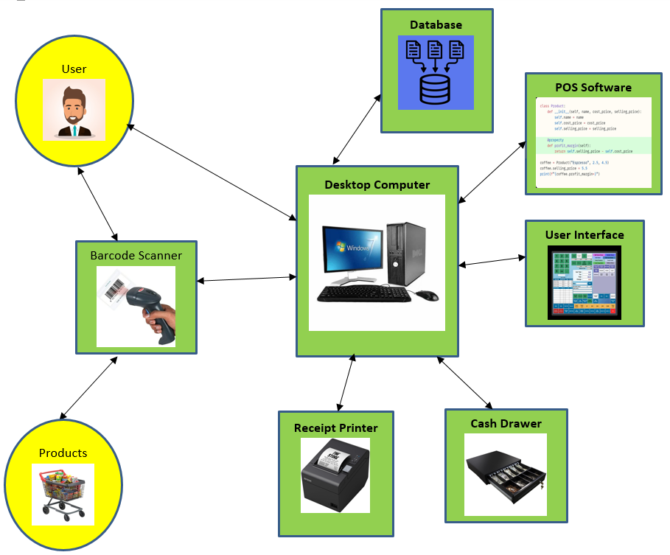

System Flow Diagram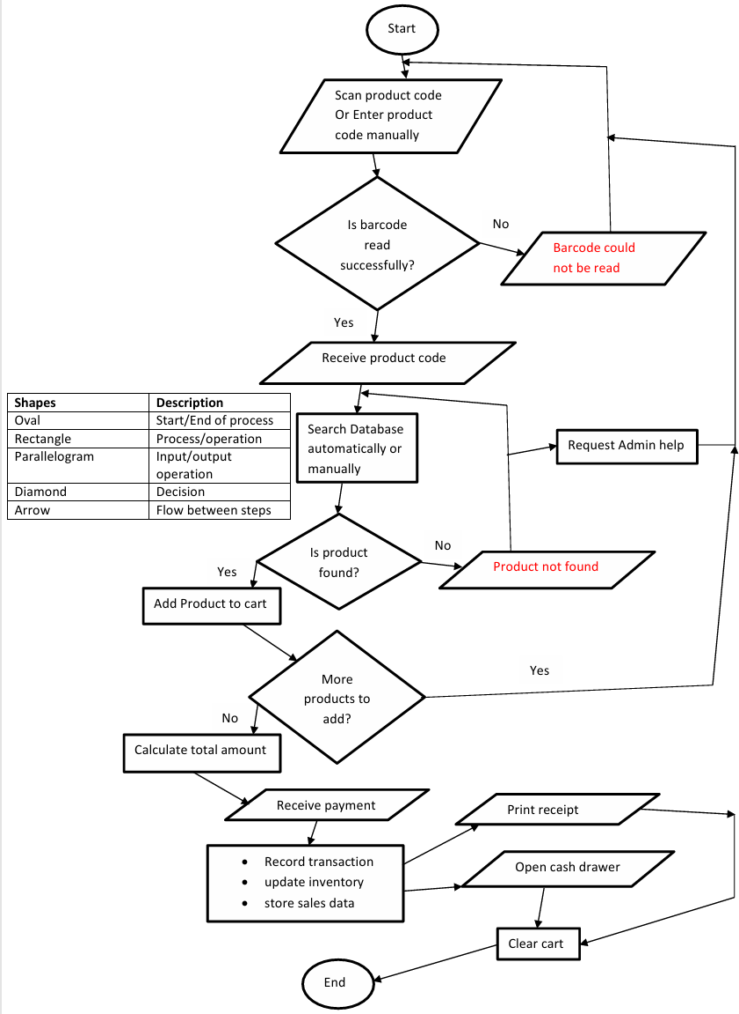

7. Database Design

Entity-Relationship Diagram

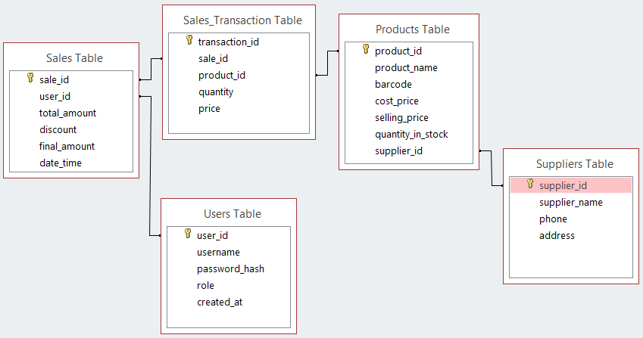

8. Tools and Technologies to Use
Component | Technology
Programming Language | Python
Graphical User Interface | Tkinter
Database | SQLite
Version Control | Git
Repository Hosting | GitHub
Packaging Tool | PyInstaller
Documentation | Microsoft Word
Operating System | Windows 10
Code Editor | Visual Studio Code (VS Code)
Entity-Relationship (ER) Diagram | Microsoft Access
High-Fidelity Prototype (System Architecture) | Microsoft Word
System Flow Diagram | Microsoft Word
Gantt Chart (Project Schedule) | Microsoft Excel
Low-fidelity Prototype | Draw.io Diagrams
Screen Recording Video updates | Snipping Tool

9. Project Schedule
Gantt chart

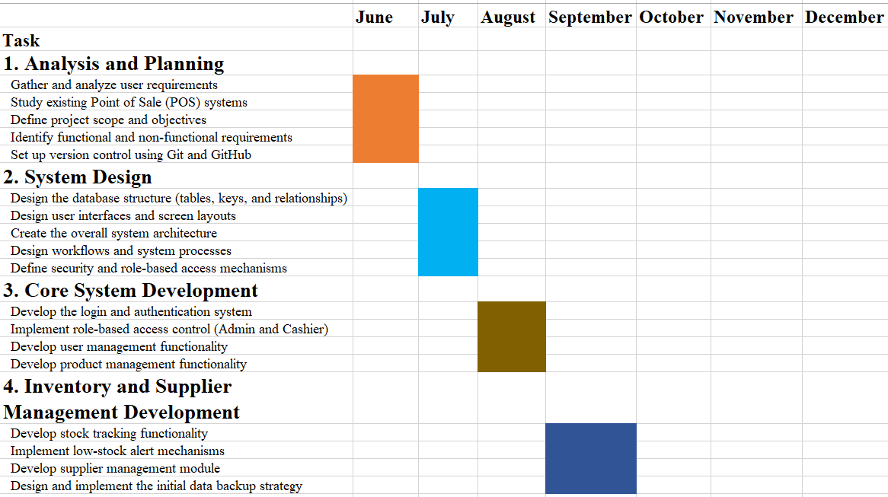

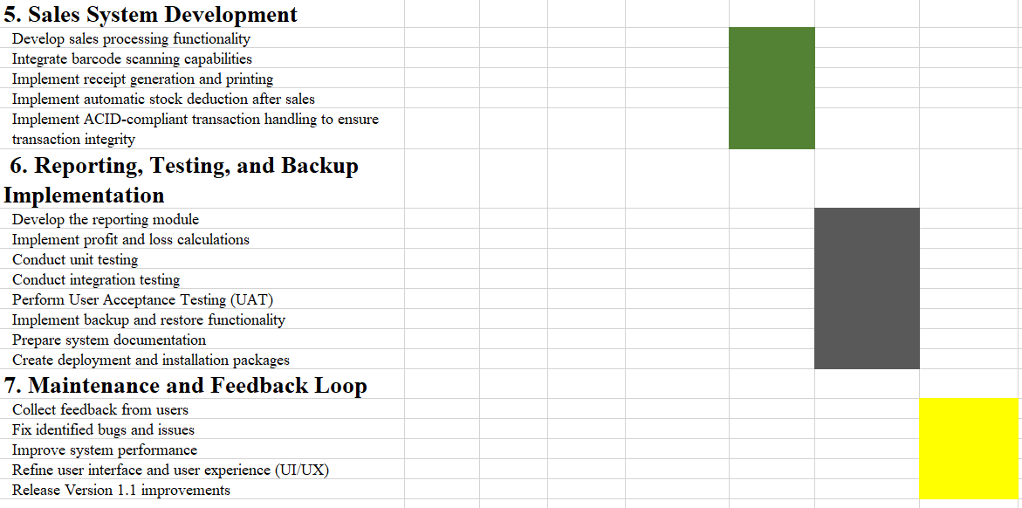

10. Low-Fidelity Prototype

Login

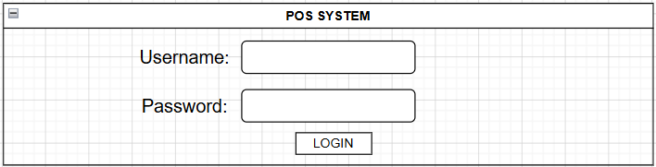

Admin Dashboard
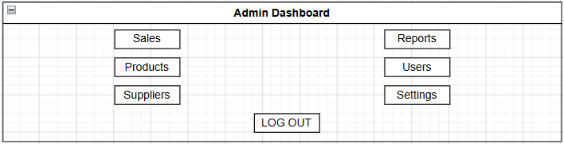

Cashier Dashboard


Product Management

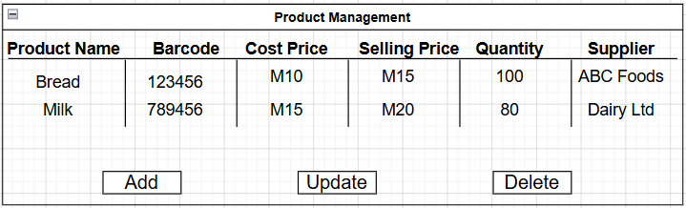

Supplier Management
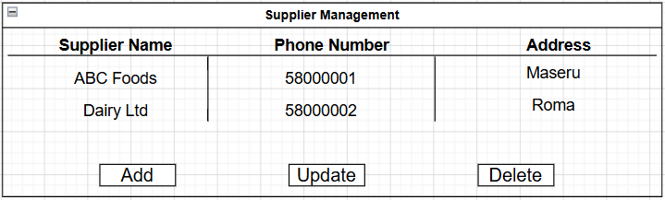

User Management
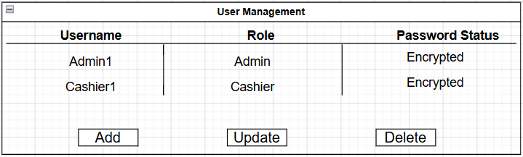

Sales
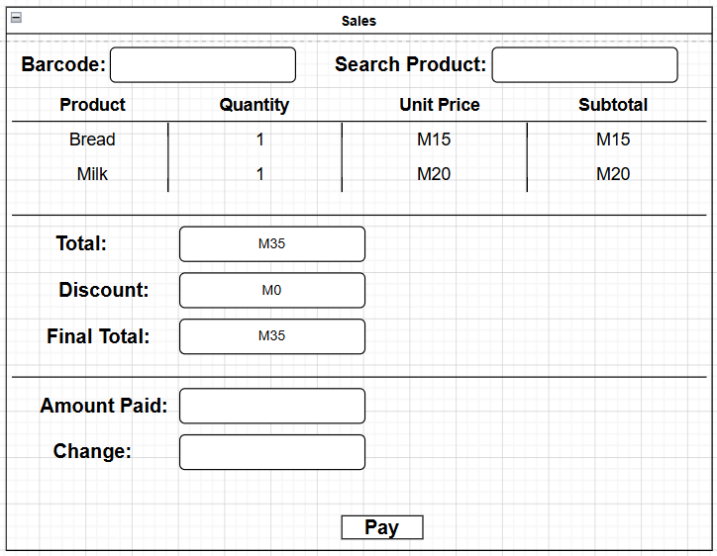

11. Conclusion
This project proposes the development of an offline Point of Sale (POS) system tailored for small businesses in Lesotho.
The system will automate sales processing, inventory management, supplier tracking, and financial reporting while ensuring accuracy, efficiency, and reliability through proper database design and ACID transaction handling.
By replacing manual systems with a digital solution, the project aims to improve business efficiency and support local economic growth while demonstrating practical application of software engineering principles.

